Abstract title
A. B. Author¹, C. D. Presentingauthor², E. Viceauthor², F. Alsoauthor¹ and G. H. Lastauthor¹
¹Institute for Dynamical Studies and Solid Properties, Anytown, Anyland
²Another Institute for Other Studies, Elsewhere
corresponding_author@email.address

We would like you to kindly submit your abstract as a single A4 page Word document by overwriting this template. Overwriting this document instead of starting a new one will preserve all the styles facilitating automated document processing. If you copy & paste text portions from another document, please use strictly the Keep Text Only paste option (by right-clicking in your Word document, open the local menu and choose Keep Text Only from the Paste Options).
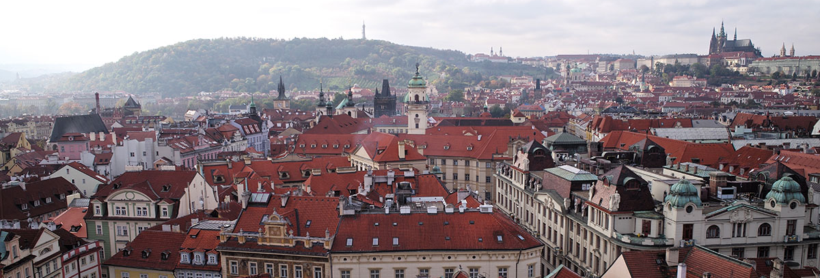
Fig. 1: The historical city of Prague.

The abstract should be typed in English using Calibri font; please avoid using condensed character spacing. The title is in 16 pt bold, author names in 13 pt normal, affiliations and e-mail contact in 11 pt italics, all centred. The body is in 13 pt normal, justified. Acknowledgements and References are in 10 pt normal. Avoid using condensed character spacing. The presenting author should be underlined. If you provide references, please keep the format provided [1, 2], including separation of the author initials and surnames by a nonbreaking space (Ctrl + Shift + Space). The text may contain small tables or figures.

The abstracts should be submitted through our web-based upload form at

https://imf2027.fzu.cz/index.php?item=abstracts

You can find more information on the event website: https://imf2027.fzu.cz/

Acknowledgements: The conference organizers will highly appreciate your contribution submission.

[1] A. Author, B. Author, C. Author and D. Author, Journal Title Abbrev. 17, 1234 (2018).
[2] A. Author and B. Author, Book Title, pp. 10–75, Publisher (2018).

